***Fatima bint Naseer***

***BSAI_3A_050***

**LUHN Algorithm:**

This Python program verifies if a credit card number is valid using the **Luhn algorithm**. It turns the number into a list of digits, doubles every second digit from the right, subtracts 9 if the result is over 9, and then adds all the digits together. If the total is a multiple of 10, the card is valid; otherwise, it's not. The program also tests this with a sample card number.

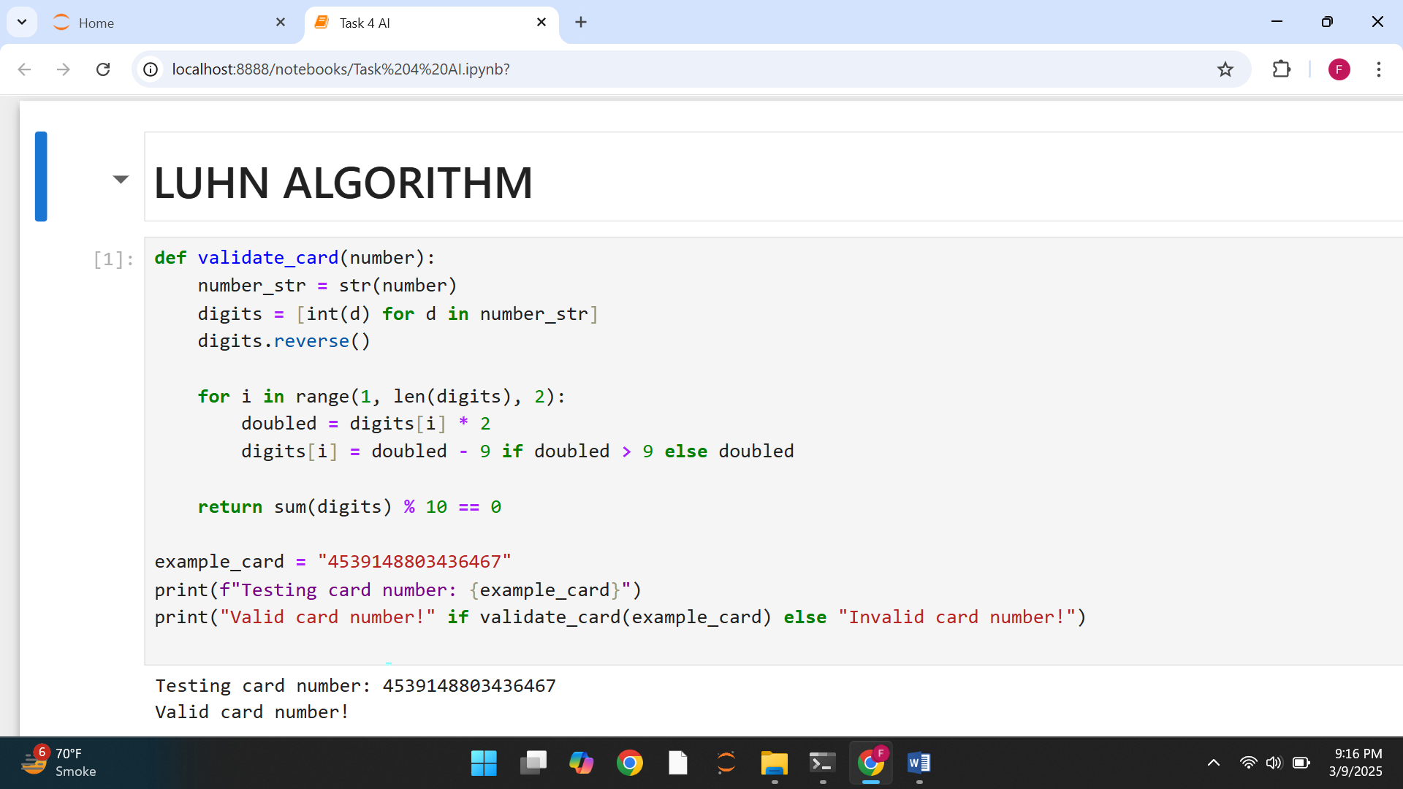

**Remove punctuation**:

This Python program takes a text input and removes any punctuation from it. The **remove_punctuation()** function goes through each character, keeping only letters, numbers, and spaces while removing special symbols like **! , . ? @ #**. Finally, it prints the text without punctuation.

